2nd June 2021

YOKOHAMA to support 4 teams / 7cars competing in 2021 Nürburgring 24-Hour Endurance Race

YOKOHAMA is pleased to announce that it will be supplying its ADVAN racing tyres for seven cars entered by four teams competing in the 49th Nürburgring 24-Hour Endurance Race (49th ADAC TOTAL 24h-Rennen) to be run in Germany on 3rd - 6th June. The supported teams include Walkenhorst Motorsport, a BMW customer racing team that entered into a partnership agreement with YOKOHAMA last year. Four Walkenhorst machines will run on ADVAN tyres, including three BMW M6 GT3 cars competing in the top-level SP9 class. The cars will use ADVAN A005 tyres for dry conditions and ADVAN A006 tyres for wet conditions.

The supported Walkenhorst Motorsport teams in the SP9 class include teams led by David Pittard, the SP9 Pro class champion in the 2020 Nürburgring Endurance Series (NLS), and Jörg Müller, a former BMW Works driver known for his excellent performances in FIA World Touring Car Championship (WTCC) and SUPER GT races. YOKOHAMA also is supporting the Walkenhorst BMW M4 GT4 that finished first by a full lap among SP10 class cars in the Qualify race held in May. In addition to the Walkenhorst Motorsport teams, three other teams will race on ADVAN tyres in the AT, SP3, and SP4 classes.

The consumer tyre business in YOKOHAMA’s new three-year (2021–2023) medium-term management plan, Yokohama Transformation 2023 (YX2023), aims to maximize the sales ratios of high-value-added YOKOHAMA tyres, namely the global flagship ADVAN brand, the GEOLANDAR brand of tyres for SUVs and pickup trucks, and various winter tyres. YX2023 positions participation in motorsports activities as crucial to the company’s effort to develop new tyre technologies that will further strengthen the ADVAN and GEOLANDAR brands. YOKOHAMA therefore is again participating in a wide variety of motorsports events in Japan and around the globe, from top-category to grassroots events.

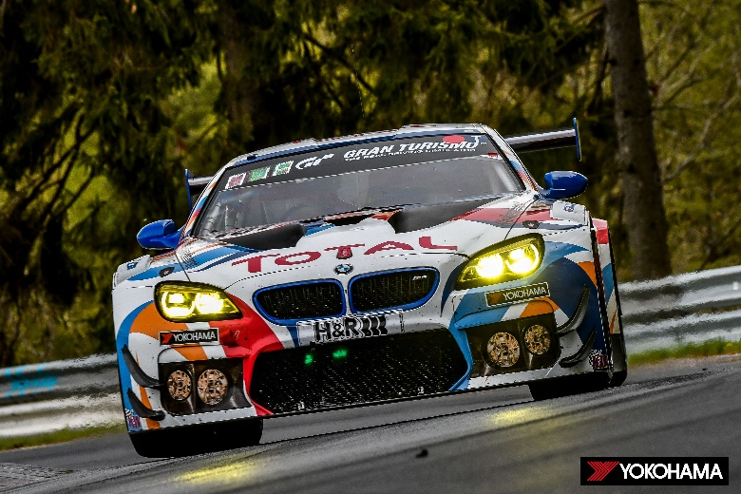
#101 BMW M6 GT3

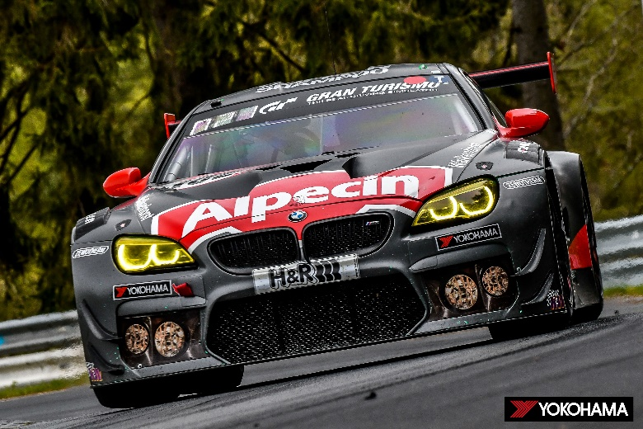
#102 BMW M6 GT3

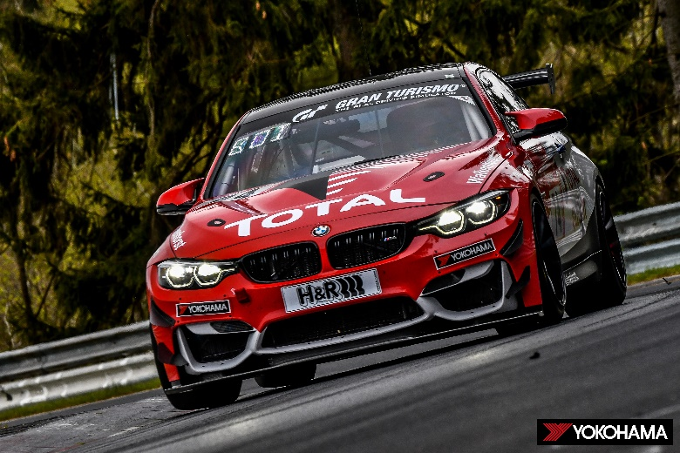
#74 BMW M4 GT4

